Wheelchair Transportation service for Abilities Expo
AFA Service (Zone 2 – Gateway Cities Region)
- Available for trips up to 12 miles within service area
- First come, first served — availability is not guaranteed
- Bookings are available on the same day only. Booking opens at 7am.
- Book using Promo Code: AFA002
Service Area:
Bellflower – 90706, 90707
Compton – 90220, 90221, 90222, 90223, 90224
Downey – 90239, 90240, 90241, 90242
Huntington Park – 90001, 90255
Long Beach – 90801, 90802, 90803, 90804, 90805, 90806, 90807, 90808, 90809, 90810, 90813, 90814, 90815, 90822, 90831,90832, 90833, 90834, 90835, 90840, 90842, 90844, 90846, 90847, 90848, 90853, 90895, 90899
Lakewood – 90711, 90712, 90713, 90714, 90715
Lynwood – 90002, 90059, 90262
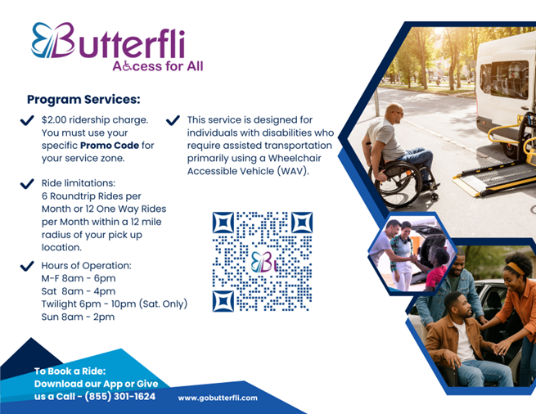

Butterfli Discounted Rates
Butterfli is offering a 25% discounted price available to anyone traveling to the Abilities Expo. To book, enter promo code (Ability26) when booking your ride. Please contact us for any questions 855-267-2354.

